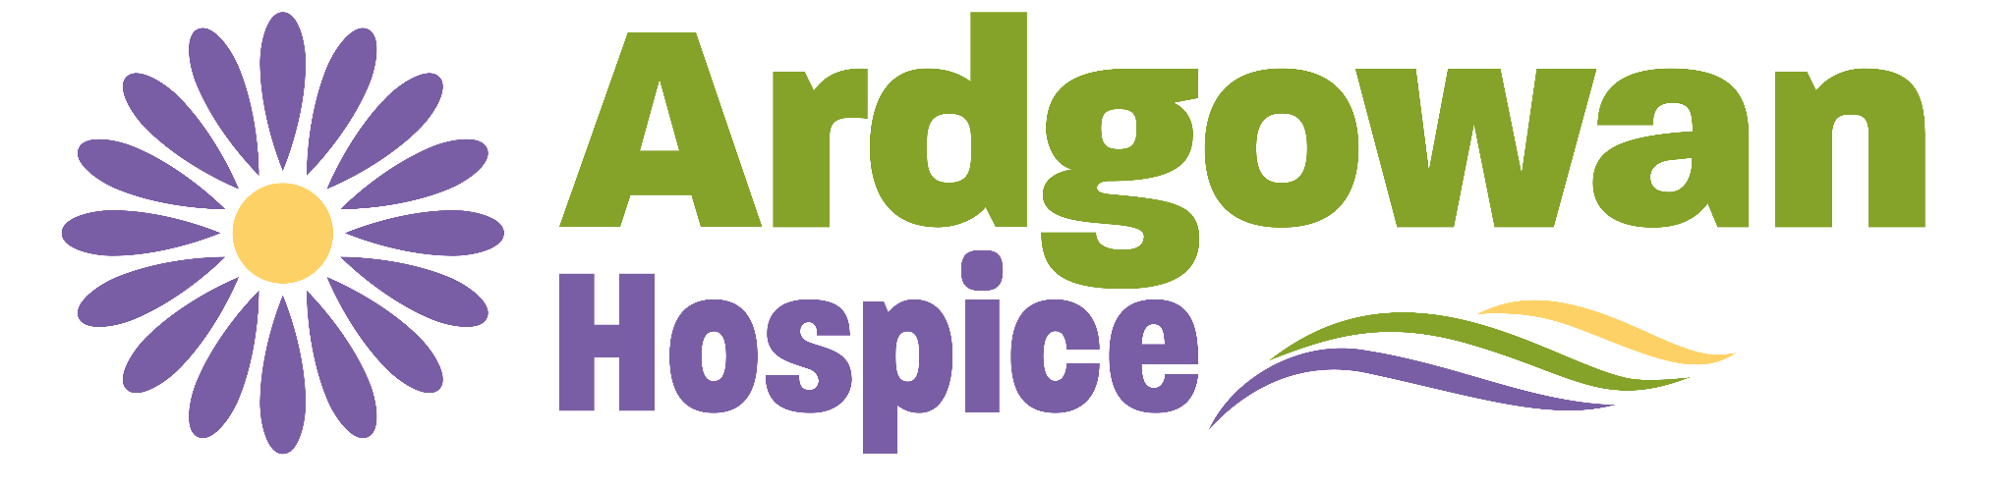

Job Title | Bank Cook
Team | Catering - Operations Support
Band/Salary Range | Step 2a - £26,300
Hours | Monday - Sunday 08:00-18:00 (must be available weekdays)

About Ardgowan Hospice, Our Values and Behaviours
Our Mission
Ardgowan Hospice is a compassionate place of care for people living in Inverclyde who have been diagnosed with a life-limiting illness, such as cancer, heart failure, lung disease, kidney failure or neurological conditions.
We care passionately about making every moment matter and improving quality of life.
In this role, you are expected to follow our values, demonstrating your commitment to delivering high-quality services to patients at all times.
Our Values
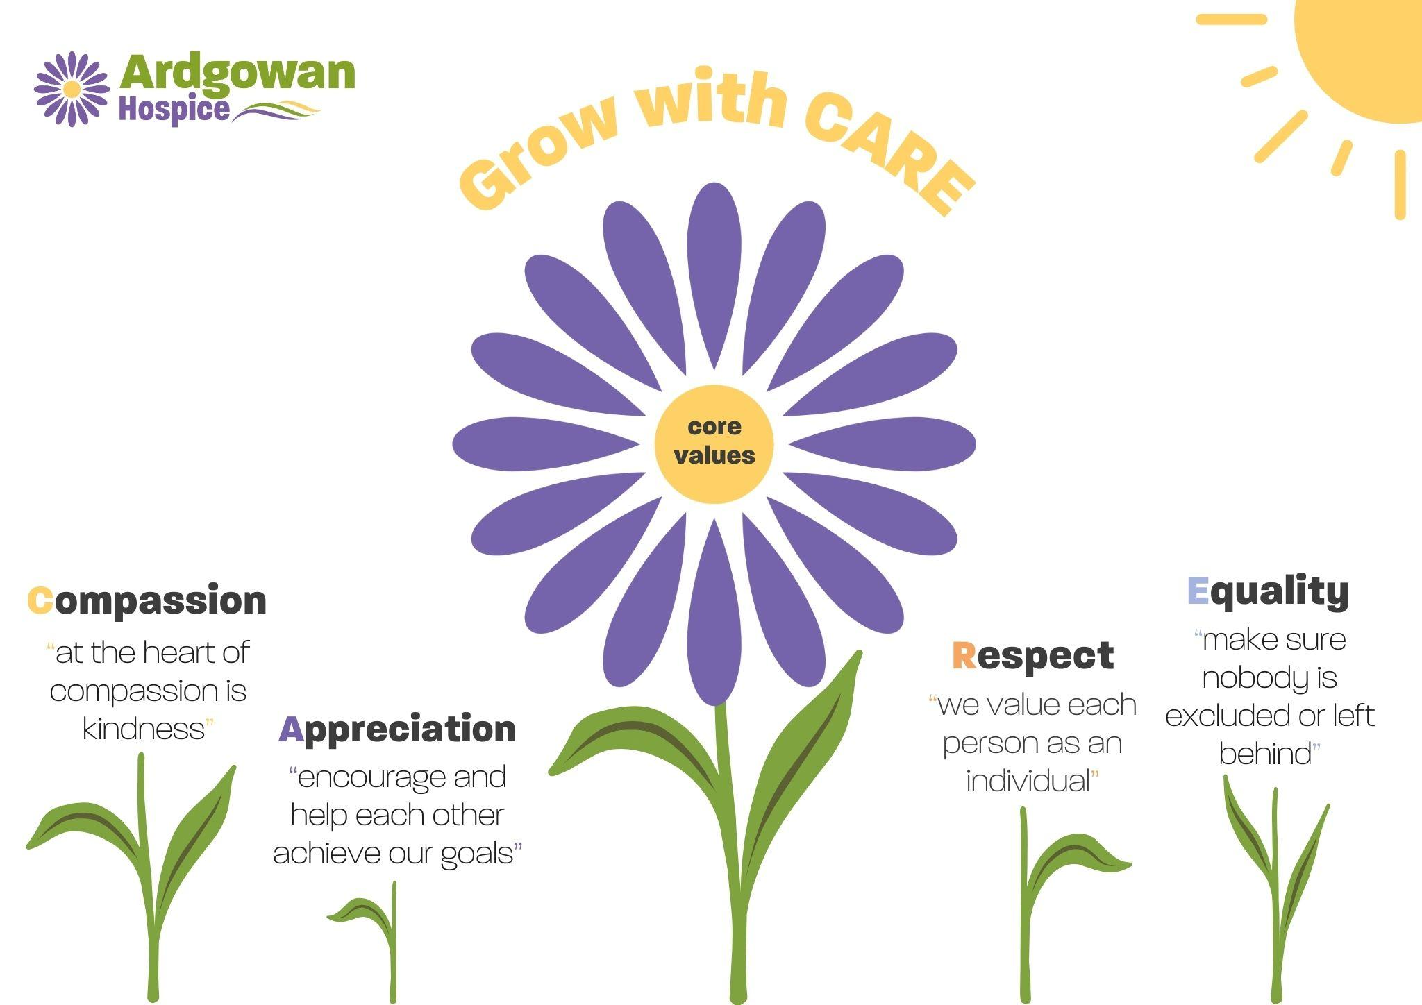

Your Main Role/Job Summary.
The postholder will be responsible for
- Create nutritious meals that meet our patients needs using fresh, quality produce
- Demonstrate understanding and practical application of specific dietary needs, i.e. allergens, nutritional requirements
- Liaise with patients & IPU team members to ensure that patients catering/dietary requirements are understood and delivered
- Work effectively and efficiently to ensure catering requirements are produced in a timely manner and in line with protected meal times
- Operate in a clean, safe and hygienic manner and in line with all regulatory and legislative requirements
- Maintain and up to date working knowledge of current legislation and complete any relevant training to support this
- Carry out daily/weekly/monthly cleaning schedules to a high standard in line with organisational and legislative guidelines
- Effectively manage stock control to ensure optimum utilisation which is cost effective
- Complete all mandatory training within required timescales
- Participate in scheduled and ad-hoc audits and checks
- Work collaboratively with other team members and internal team members to provide the best possible service across the organisation
- Demonstrate flexibility where required to ensure we always meet the needs of our patients
- Undertake other ad-hoc duties as required by the organisation

About you.
Warm and friendly with the ability to engage effectively with patients, families, visitors and Ardgowan employees. The ideal candidate will recognise the importance mealtime plays in our patient’s experience and will endeavour at all times to ensure that patient’s needs and requests are fully met. A confident cook who can work as part of the wider catering team whilst having the ability to work independently and with a proactive approach to their role.
In the first six months, you’ll:
- Receive training and guidance on the regulatory requirements for the role
- Demonstrate a willingness to learn and understand how the kitchen operates
- Engage with patients and families regularly adapting your approach and style of cooking dependant on patient needs
- Add value to how the kitchen operates bringing forward new ideas and initiatives

The Team
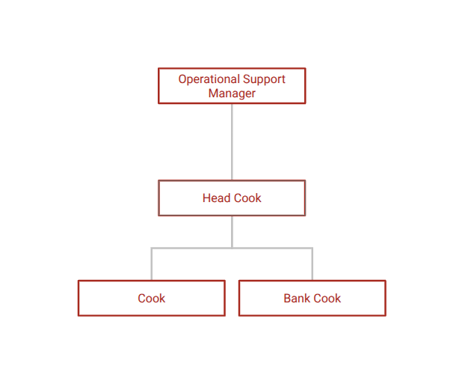

Key Relationships – Internal & External
Patients
Families & Visitors
Catering Team
IPU Team
All Ardgowan Teams

Learning & Development
You are expected to complete the following induction training relevant to your role, including
- Fire Safety
- Health and Safety, an introduction
- Reducing Risks of Violence & Aggression
- Equality and Human Rights
- Manual Handling Theory
- Public Protection (Adult & Child)
- Standard Infection Control Precautions (NES: Scottish IPC Education Pathway (mandatory modules: Breaking the Chain of Infection; Why Infection, Prevention and Control Matters; Respiratory Cough Hygiene; Hand Hygiene))
- Security & Threat
- Safe Information Handling
- Asset-based Community Development

You are also expected to reflect on your practice, identify improvement areas and contribute to your annual personal development plan.

Job Criteria
List the most important criteria the person needs to demonstrate to be successful at the job. There should be no more than 10 in total.
Criteria | Application | Test | Interview
Values-based
- Treats people with compassion and respect |  |  | ✓
- Works together with others |  |  | ✓
- Proven ability to interact with people in a way that inspires trust and confidence. | ✓
- Has a good understanding of the Asset Based Approach |  |  | ✓
Technical Skills & Knowledge
- Experience in administrative and/or reception work | ✓ |  | ✓
- Be solution focused in approach. | ✓
- Good planning and organisational skills | ✓ |  | ✓
- Strong interpersonal and communication skills. |  |  | ✓
- Knowledge and ability to utilise information technology, including email, Internet and database use. | ✓
- Awareness of confidentiality | ✓ |  | ✓

